Install App

Search and install CardCam on google play. After installation you will see an icon with name CardCam.

Activity flow when tab on app shortcut

 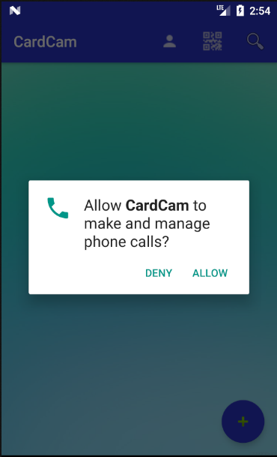

Allow permisiions

You will see tootltips when run application first time. You can hide a tooltip by tab on the tooltip or cross button.

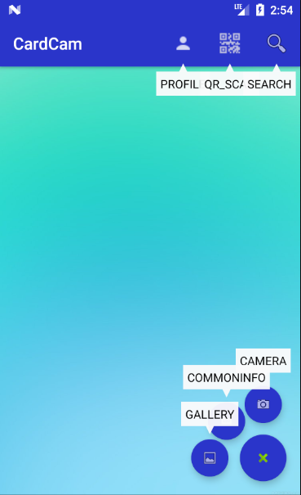

Some options you should know.

Search option tab there

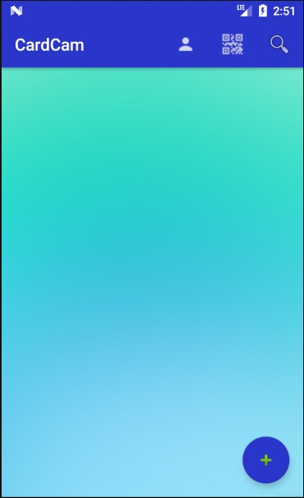

Fab button tab her for more option

Profile view

Qr scanner for for

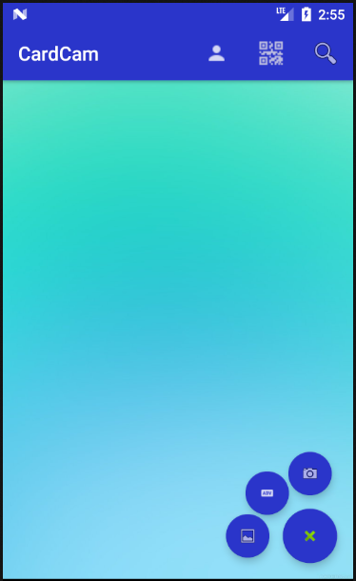

Choose image from gallery

Capture image usingCamera

Other detail window

Update your details on profile view.

To update your details tab profile action shown above and click edit action on created view.

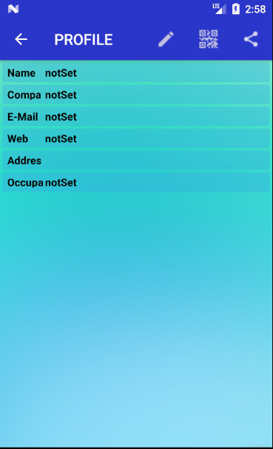

Tab here for edit info

Tab here for share you info with others

Tab here for share all data

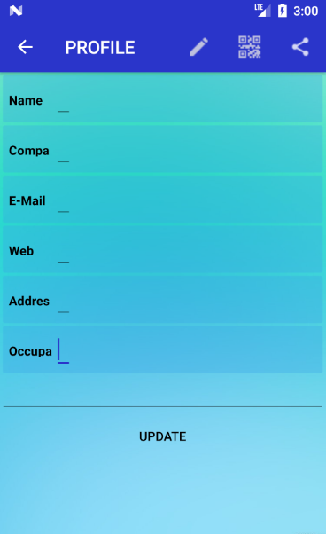

Enter details here you want to add

Edit your information

If you tab on share button on profile view it will show you share and download options.



Tab here for download contact details

Tab here for share all details

Tab search action on main view for search using filters. It will create a search option view.

